**Fundamentals of Computer Programming**

**Building a Programming Portfolio**

**Week 4**

You should be able to complete the following programs by the end of the week. You should keep the code somewhere safe, in an organised way. GitHub is ideal. Wherever you choose, you should ensure that the work is safe and backed up.

Possible solutions will be uploaded to the main module GitHub repository every week. If you follow that repo you should be able to receive notifications.

1. Functions are often used to validate input. Write a function that accepts a single integer as a parameter and returns True if the integer is in the range 0 to 100 (inclusive), or False otherwise. Write a short program to test the function.

Firstly, I created a function which accepts a single integer.

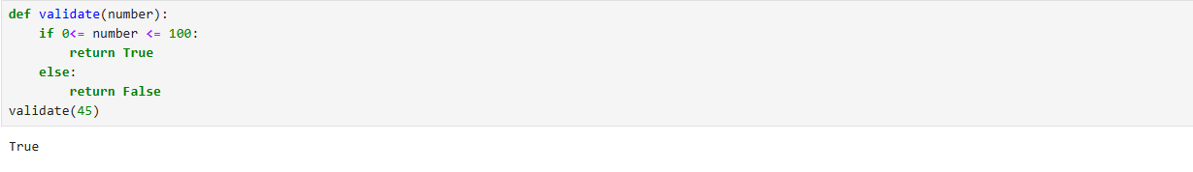

Secondly, I edited some of the codes and created different function for accepting the input from the user and user entered number greater than 100 that returned false.

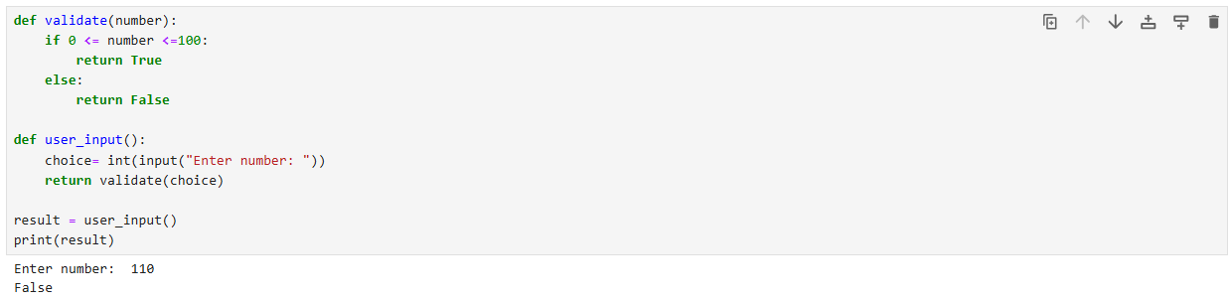

1. Write a function that has a single string as its parameter, and returns the number of uppercase letters, and the number of lowercase letters in the string. Test the function with a short program.

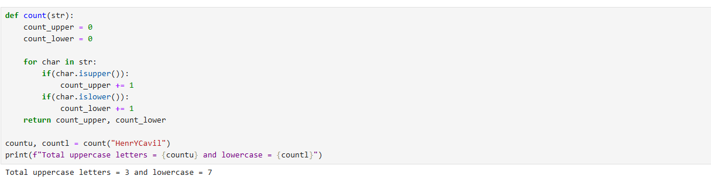

1. Modify your "greetings" program so that the first letter of the name entered is always in uppercase with the rest in lowercase. This should happen even if the user entered their name dierently. So if the user entered arthur, ARTHUR, or even arTHur the name should be displayed as Arthur.

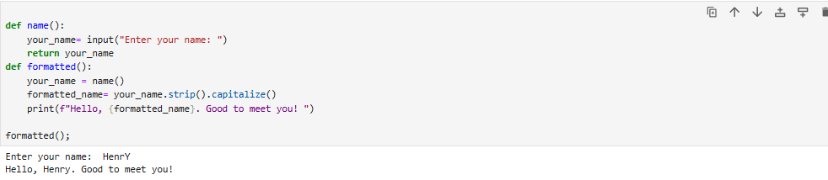

1. When processing data it is oen useful to remove the last character from some input (it is oen a newline). Write and test a function that takes a string parameter and returns it with the last character removed. (If the string contains one or fewer characters, return it unchanged.)

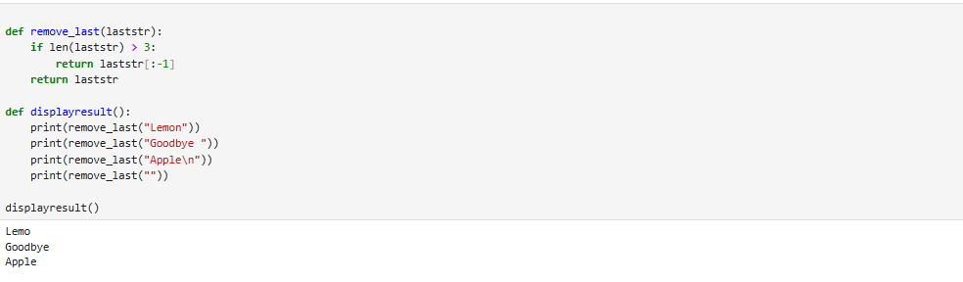

1. Write and test a function that converts a temperature measured in degrees centigrade into the equivalent in fahrenheit, and another that does the reverse conversion. Test both functions. (Google will find you the formulae).

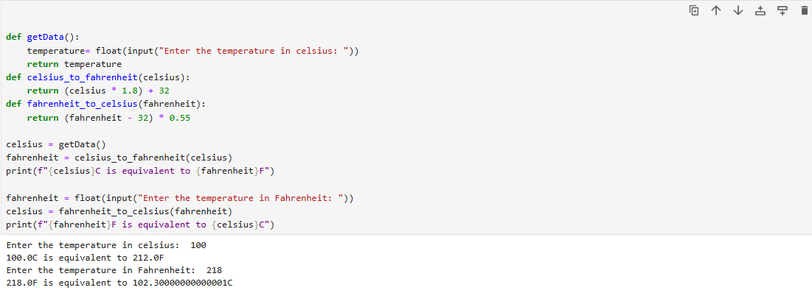

1. Write a program that takes a centigrade temperature and displays the equivalent in fahrenheit. The input should be a number followed by a letter C. The output should be in the same format.

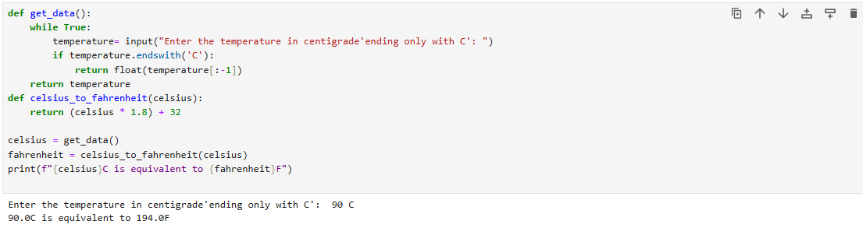

1. Write a program that reads 6 temperatures (in the same format as before), and displays the maximum, minimum, and mean of the values. Hint: You should know there are built-in functions for max and min. If you hunt, you might also find one for the mean.

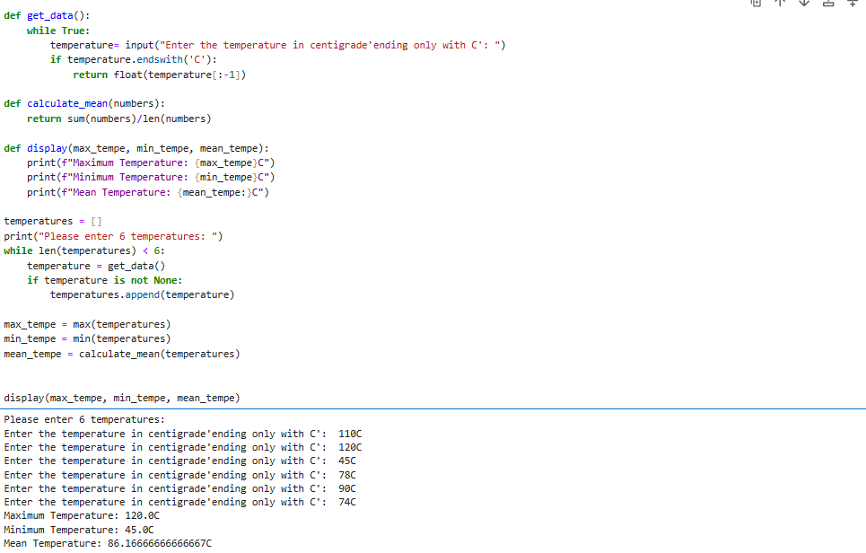

1. Modify the previous program so that it can process any number of values. The input terminates when the user just pressed "Enter" at the prompt rather than entering a value.